**NLP TASK**

**TITLE: EXPLORING COCA- Corpus of Contemporary American English**

NAME: APARAJITA SENAPATI

REG NO: 20BDS0288

**Word: Barack Obama**

**Inference after exploring the corpora for the given word-Barack Obama**

From the frequency chart we can observe that there were no or very few instances wherein Barack Obama was mentioned from the year 1990 till 2004, however there was a steep increase from then when we he was in the run for becoming the president and was elected, there were mentions of his name in various domains like the news, web, talk shows, etc. We can also observe a slight decline in the frequency after his second term when a new president was elected. On using the collocate search the most frequent word is “President.”

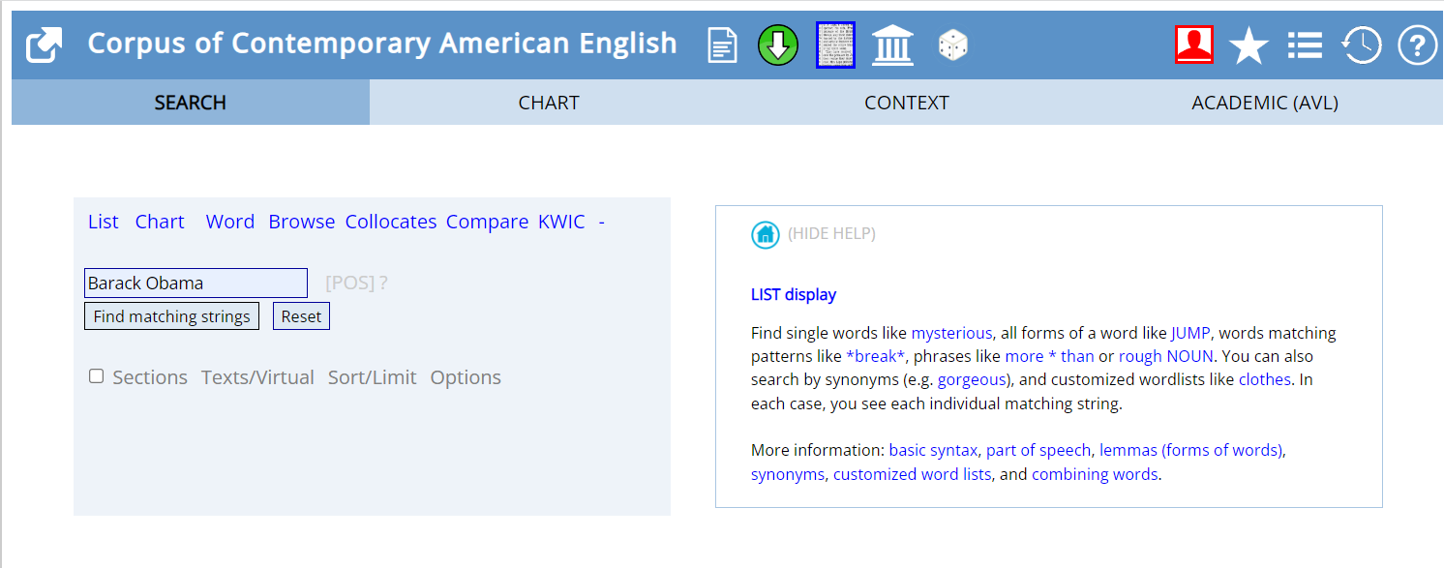

The frequency of the word Barack Obama is 23749

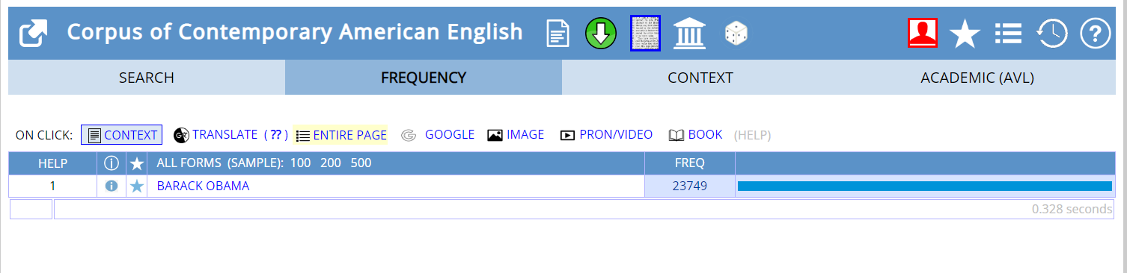

This chart displays the number of times or the frequency of the word “Barack Obama” occurs in various domains like blogs, magazines and the news and the chart on the right-hand side displays the frequency of the word for four-year intervals starting from 1990 till 2019.

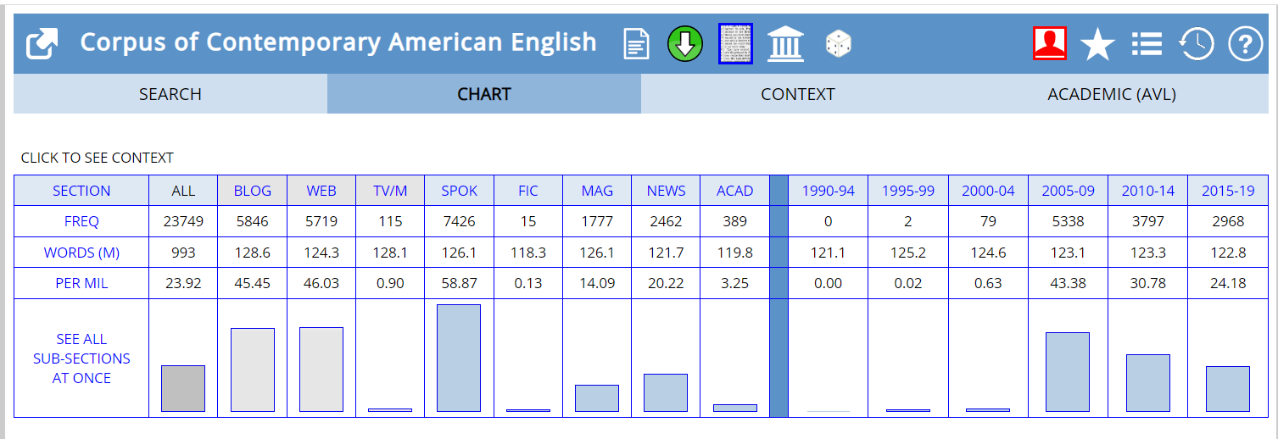

The below image displays all the subsections at once

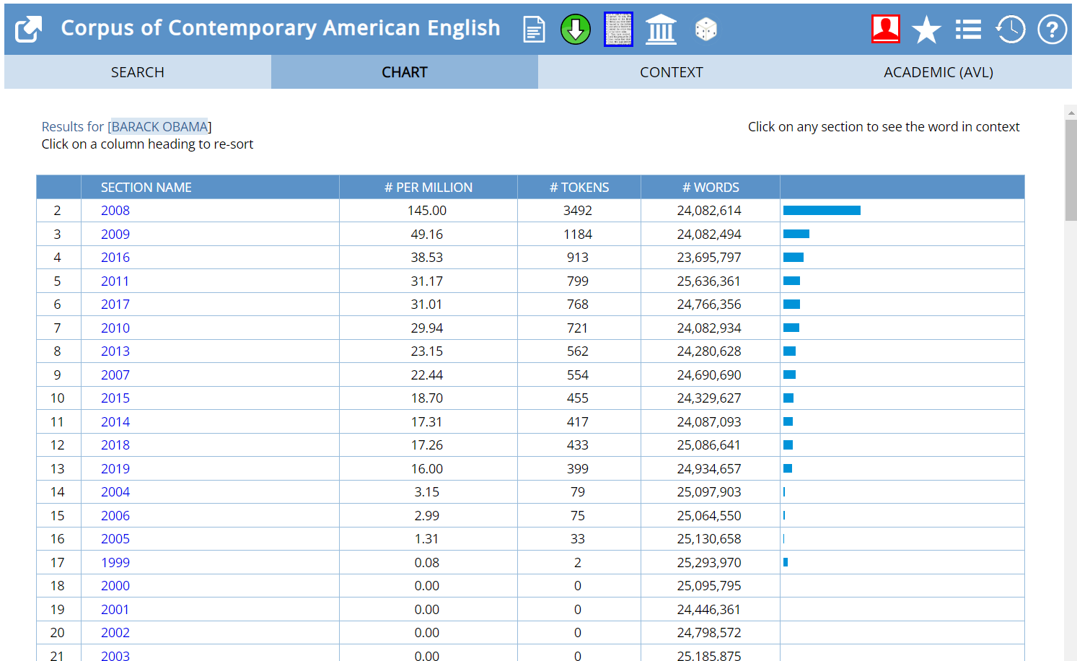

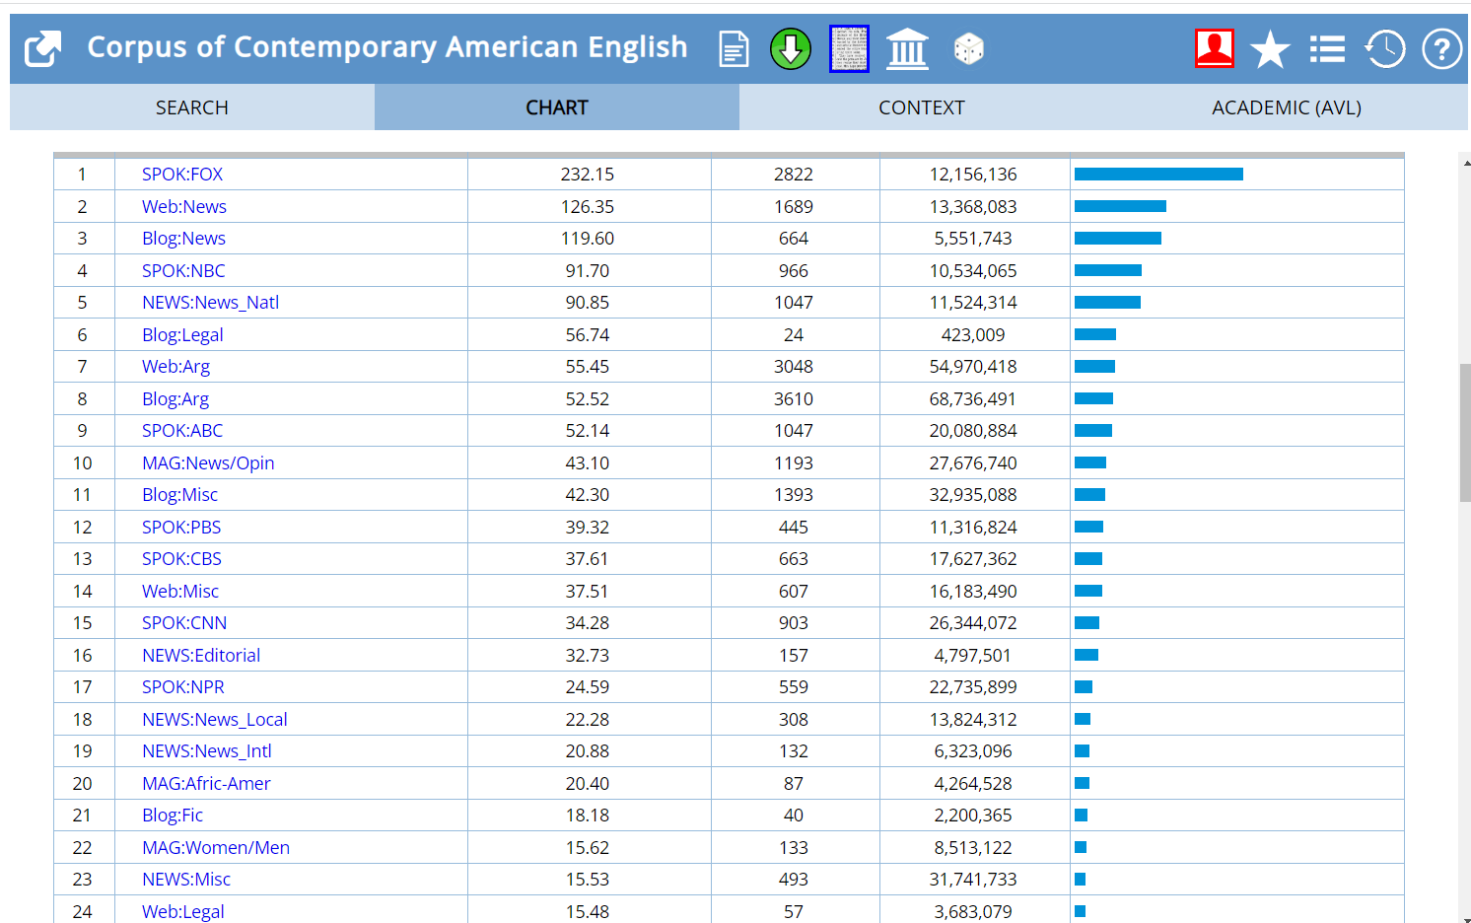

Collocates of the given word in various domains

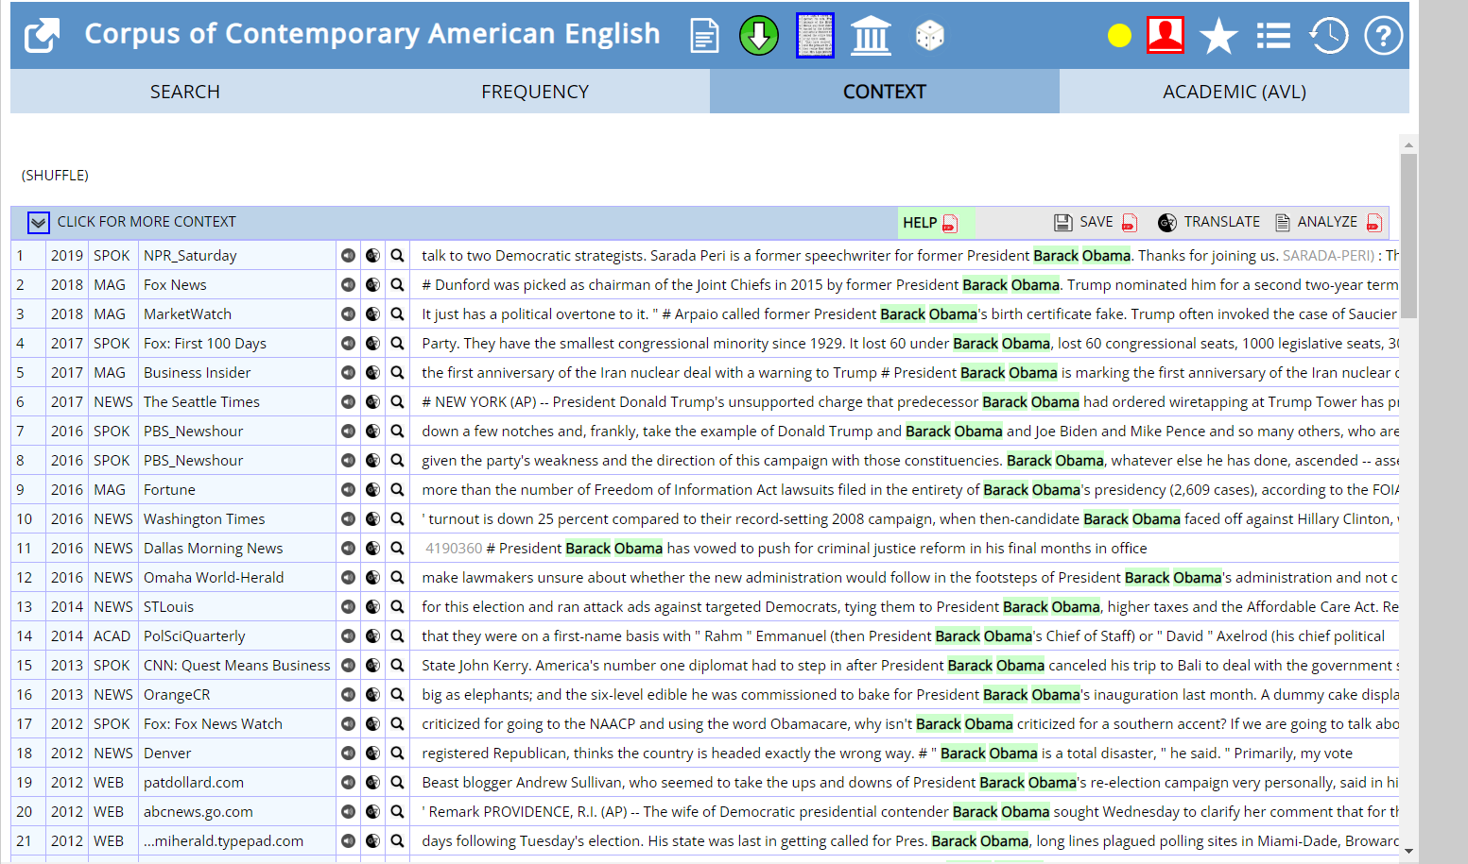

Comparison between two words: Barack Obama and Donald Trump.

